Which beak works best?
Nature Activity Sheet
Golden Gate Audubon Society

There are certain things that all birds have in common, such as wings and feathers. But other parts of their bodies differ by species (kind) of bird. Take beaks— some are long, some are short, some are straight, some are curved, and so on.

As you do this activity, think about:

- Why are there so many different kinds of bird beaks?
- What can the shape or size of a bird’s beak tell us about what that bird eats?

Preparation

Gather the following tools on your kitchen counter or table. You are a bird and these tools will be your “beak!”

- Chopsticks
- Soup spoon
- Eye dropper
- Strainer
- Tweezers
- Nutcracker
- Fork

Have a towel handy to clean up!

Then set up these different “environments,” where you will use your “beak” to catch and eat food.

- Tall, thin vase filled with water.

- Big bowl filled with dry oatmeal, cheerios, rice, or rice krispies. Bury three or four items such as raisins, grapes, or gummy worms in the cereal.

- Big bowl filled with water and rice krispies or cheerios. (Mostly water.)

- Medium sized bowl with pistachios, sunflower seeds, peanuts in the shell or other crackable nuts.

- Bowl filled with water and chunks of styrofoam, lettuce, or felt—stuff that floats.

- Bowl of popcorn.

Activity

Now it’s time to be a hungry bird! Starting with Environment #1, try the different tools to see which one works best at getting “food.” Think of each tool as a different shape of beak. Write down which one works best for each environment.

- Vase of water. This is like trying to drink nectar from the middle of a flower. Which tool is best for drinking nectar??

Tool:__________________________________________________________________________

- Bowl with buried objects. This is like a beach, where little crabs and worms are hiding in the sand. Which tool is best for picking out the buried food, while leaving the sand behind?

Tool:___________________________________________________________________________

- Bowl of water and rice krispies. This is like a lake or bay, where there are plants or marine organisms floating in the water. Which tool lets you get the food but not the water?

Tool:___________________________________________________________________________

- Bowl of nuts. These are like the seeds of many plants. Which tool lets you pick up the nuts and crack them open? Do you need more than one tool?

Tool:____________________________________________________________________________

- Bowl of water and floating objects. This is like trying to grab or stab a large fish in the water. Which tool is best for getting the items floating in the water?

Tool:______________________________________________________________________________

- Bowl of popcorn. This is like trying to catch insects while flying. Throw a piece of popcorn in the air. Which tool is best for grabbing it in mid-air?

Tool:_______________________________________________________________________________

Follow-up

Here are some pictures of different type of bird beaks. Do any of the beaks remind you of the tools you used?

Which kind of beak would work best in each of your different “environments?”
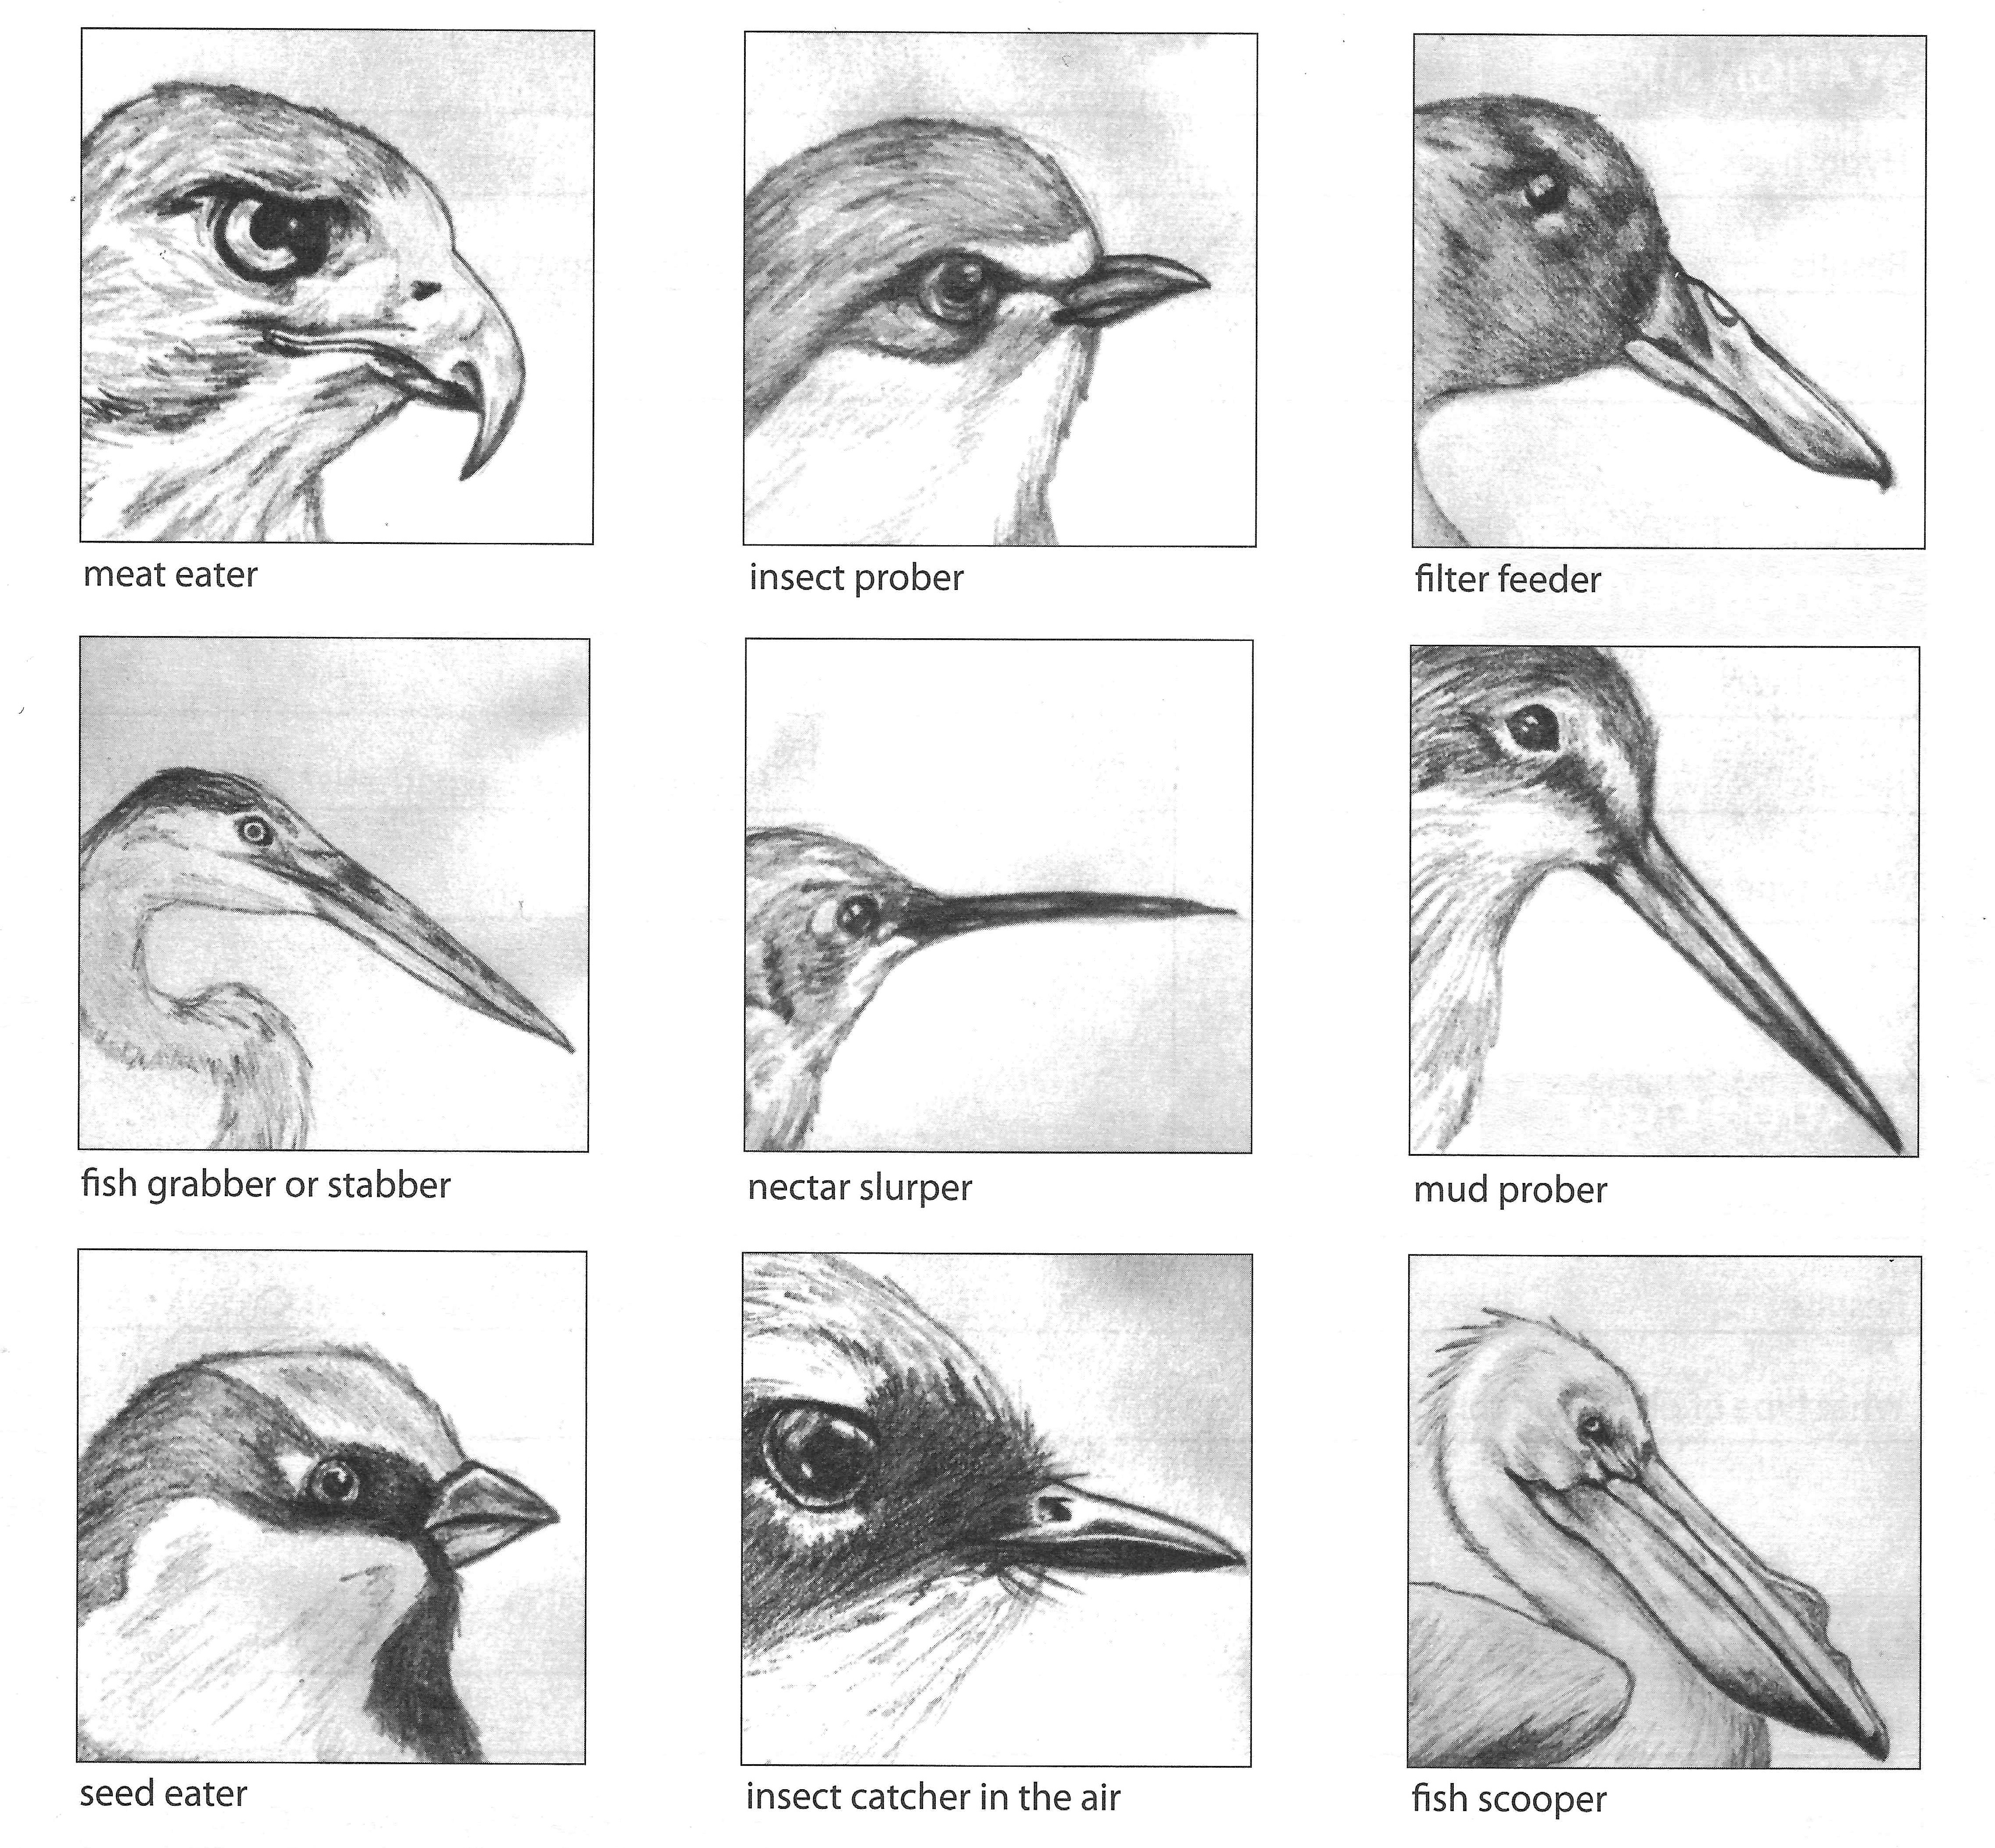

All these different beaks are an example of what is called “adaptation.” Some body shapes or behaviors make it easier for animals to survive in the habitats where they live. Over time, the animals with these traits are more likely to live long enough to reproduce, passing on these helpful traits to their offspring.

Other animals also have body parts and behaviors that help them survive. Take cats and dogs. Can you think of body parts that may have evolved to help them survive?

Finally… remember to clean up all those bowls from your experiments!!

