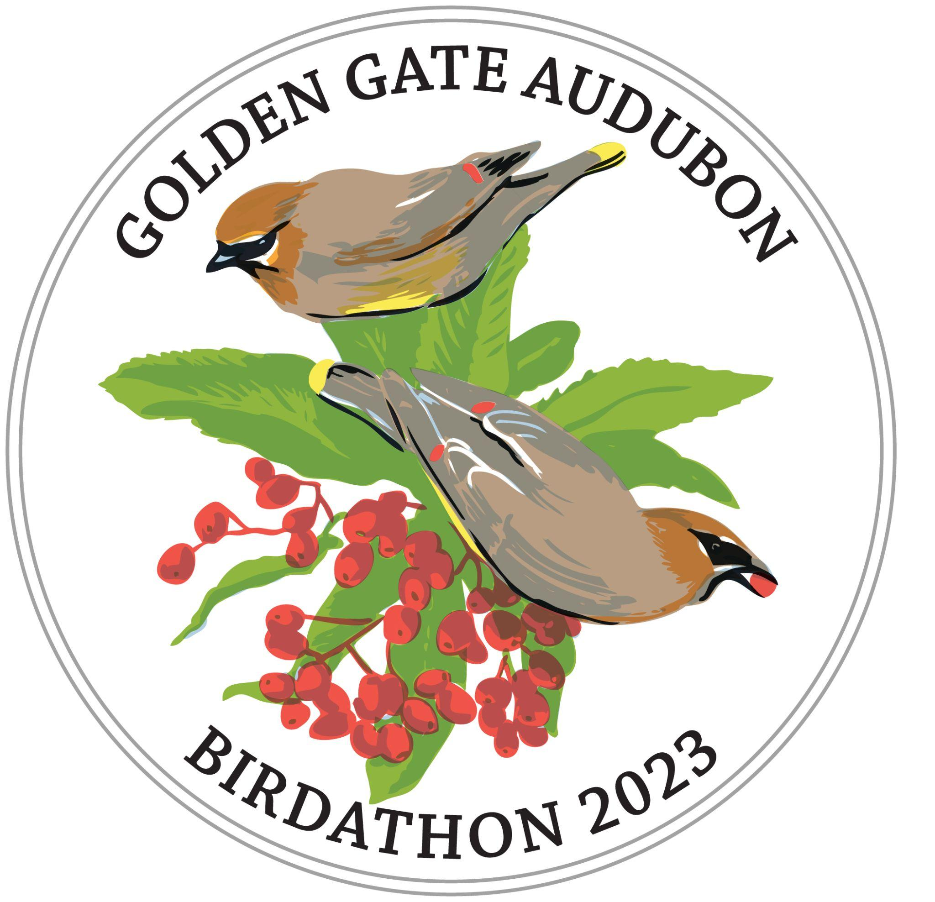
\Donation Form
Name: __________________________________________________________________
Address:_________________________________________________________________
Email Address: :___________________________________________________________
Team/Individual I am supporting:_____________________________________________

Please mail this form with cash or a check to:
Golden Gate Audubon Society
ATTN: Birdathon
2150 Allston Way Suite 210
Berkeley, CA 94704

Checks should be made payable to Golden Gate Audubon Society
Please write “Birdathon” and the name of the team or individual to which you are
donating on the memo line.

Thank you for supporting Bay Area’s birds!
For questions, please contact Membership Manager
George Marschall at gmarschall@goldengateaudubon.org or (510) 843-2222.

